**TECHNICAL REPORT ON PROJECT 2.**

**BY**

**ADEGOKE BLESSING TUNMISE**

**VEPH/20B/DA189**

**Task 16B (ii)**

**DEEJAH’S STORE PERFROMANCE ANALYSIS FOR 2014**

OUTLINE

1.     Introduction

2.     Story of Data

3.     Data Splitting

4.     Pre-Analysis

5.     In-Analysis and Insights

6.     Data Visualization

7.     Recommendations and Observations

8.     Conclusion

**1. Introduction**

This report presents a detailed overview of Deejah’s Store sales performance and provides strategic insights to improve business operations in future financial years.

**2. Story of the data**

The data is obtained from a public dataset and tells a story about the total revenue generated for this sales company selling different product categories, sold at 3 different regions with the use of 3 different payment methods.

This data was gathered through an automated script process.

Data Structure: The data is a structured data arranged in a table with rows representing the transaction ID, Product category, Product name, Units sold, Unit price, Total revenue, Region, and Payment method.

**3.Data Splitting**

Data Cleaning:

In order to ensure cleanliness of the datasets, firstly, I removed the duplicated rows and ensure there is none blank rows. I also ensured the column headings are well spelt out and the whole dataset was converted to a normal Excel table for quick updating when needed.

Handling Missing Values:

·         Replacing missing values with the columns mean and mode for categorical data.

Data Transformations:

·         Adding new columns based on condition.

·         Reshaping wide data

Data Split: The data was split into two categories. Category one is the independent values while category two is the dependent value.

Category One - Independent values

1. Product Category

2. Product Name

3. Region

4. Payment Methods

Category Two - Dependent values

1. Revenue

2. Units sold

3. Units Price

Stakeholder: C.E.O

What matters to the company: Getting more revenue in the subsequent year(s).

**4. Pre-Analysis and Intended Insights**

* I intend to determine the best performing Product category by the revenue generated.
* I intend to determine the best performing Region by the revenue generated.
* I intend to determine the most preferred Payment method.

**5. In-Analysis**

* Upon slicing, it is observed that Credit Card is used as payment method both in North America and Asia, while Debit card is only used in Asia and PayPal is only used in Europe.
* North America being the top performing region that is giving the company the highest revenue is observed to be getting her sales majorly from Electronics and Books, while the worst performing region, Asia, sold majorly Clothing and Sports products.
* Clothing is the most sold product category, though it is not giving the company more revenue compares to Electronics.
* January is the best performing month out of the 8 months we analyzed. There has been drastic slope in the sales from May to August.

**DATA VISUALIZATION**

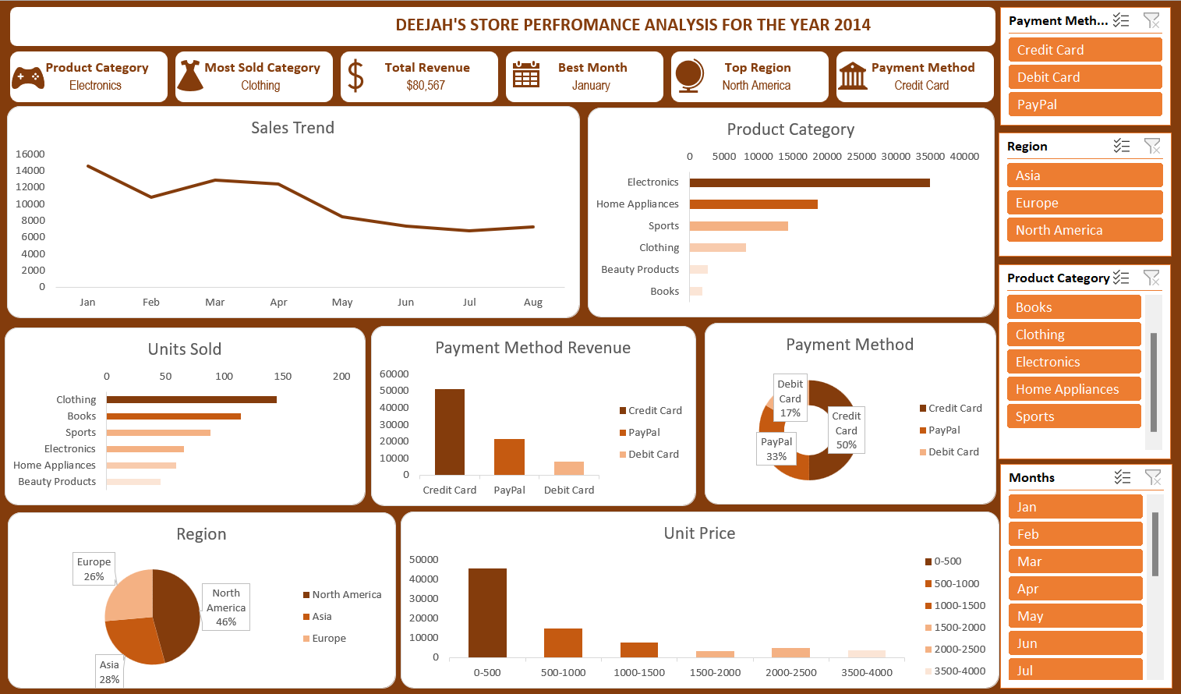

7. **Recommendations**:

1. I recommend to the stakeholders to introduce the using of another payment method in Europe and Asia as using only one payment method could hinder some customers from patronizing the company.

2. I recommend to the stakeholders to do a promo sales or advert in Asia majorly on Electronics products for the company to replicate the sales in North America in Asia also.

3. The stakeholders should compel the stock and inventory department to ensure that Electronics and Clothing products should always be replenish even before they finish up.

4. Diagnostic analysis needs to be carried out to identify the drop in sales from May to August and tackle it. Also, what was done in January should be replicated in other months to boost the company’s revenue.

**8. Conclusion:**

This analysis provides insights into the sales performance for Deejah’s store. By implementing the recommended strategies, the business can optimize revenue growth, improve market positioning, and enhance customer satisfaction.